HTML tool enhancement

Pre-requisite – Do the required changes in the fine-tuning-data-builder-html file and then reload this in the browser.

- Enhanced the application by adding support of Cypress with JavaScript
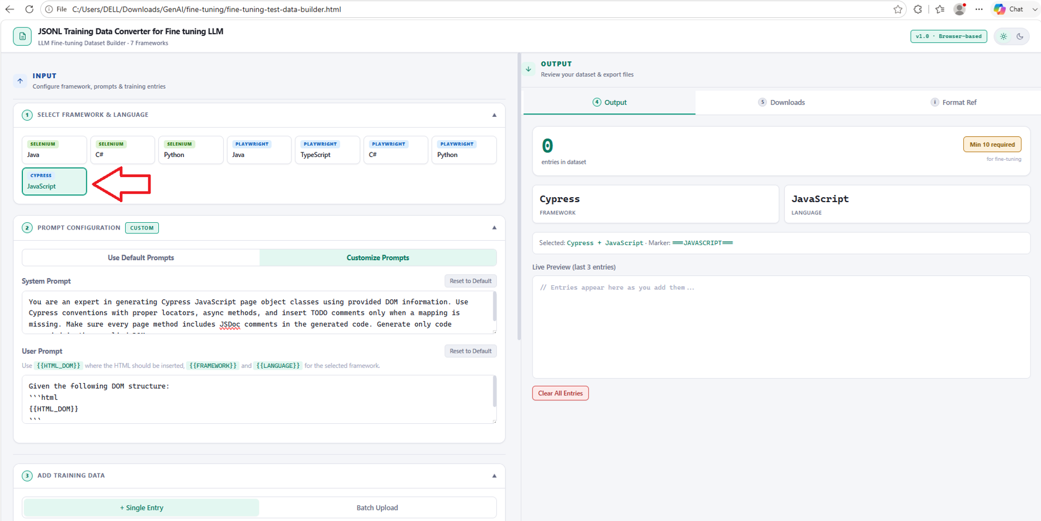

- Generate jsonl output files for the above added configuration
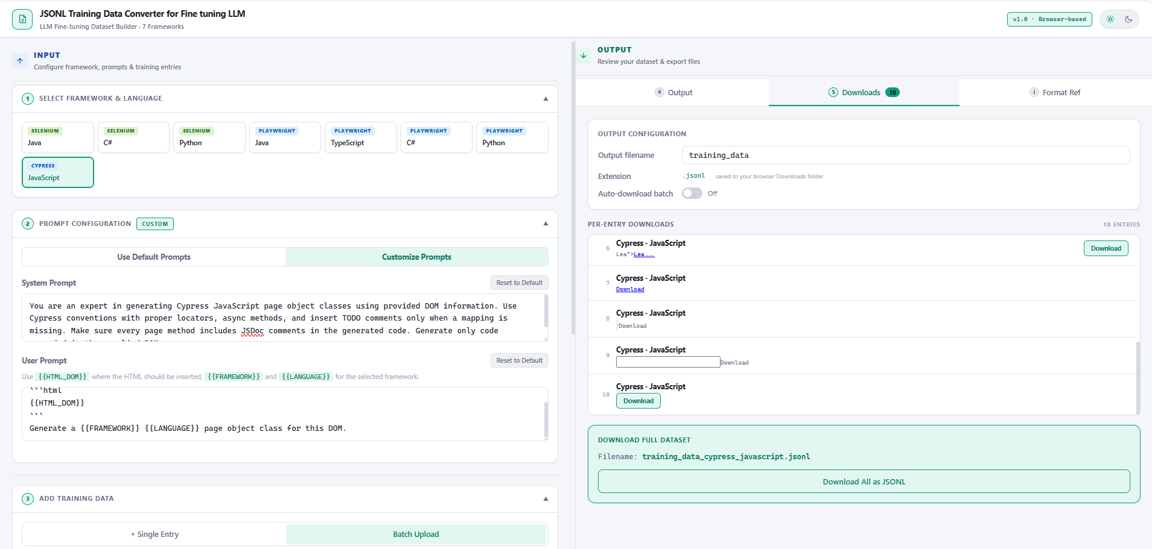

- Download the generated jsonl file
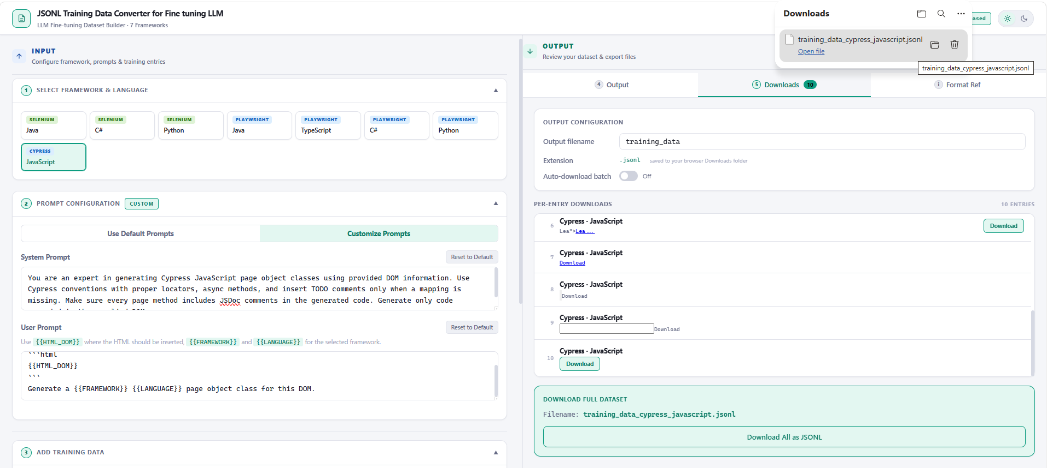

- Go to JSONL formatter, format the existing jsonl file and download the formatted file
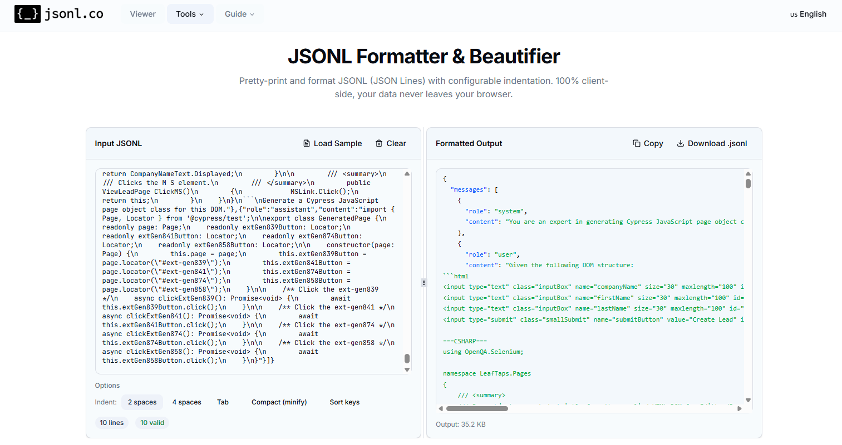

- Below is the formatted JSONL file

